**Wi-fi Based Home Automation Using ESP8266 and Blynk Iot**

Roshan Jadhav

Department of Electronics and Telecoomunication Engg. Pune, India

roshan.22220205@viit.ac.in

Krishna Borakhade

Department of Electronics and Telecoomunication Engg. Pune, India

krishna.22220093@viit.ac.in

Shreya Atkari

Department of Electronics and Telecoomunication Engg. Pune, India

Shreya.22220256@viit.ac.in

Dr. Pravin Gawande

Department of Electronics and Telecoomunication Engg. Pune, India

Pravin.gawande@viit.ac.in

***Abstract*-**

***This research presents an IoT-based home automation with Blynk app using ESP8266 for* employing a 4-relay module, ESP8266 and the Blynk app, this home automation initiative establishes an intelligent and easily accessible system. The 4-relay module functions as a versatile switchboard, providing control over multiple electrical devices within a household. Acting as the central processing unit, the compact and Wi-Fi-enabled ESP8266 facilitates seamless internet connectivity, enabling remote access. Central to the project is the Blynk app, tailored for IoT applications, which contributes significantly. This application furnishes an intuitive and user-friendly interface on smartphones or tablets, allowing users to effortlessly monitor and control connected devices. The integration of the Blynk app enriches the user experience by offering a convenient and accessible method for managing home appliances with a tap on their mobile devices.**

***Keyword:- Industrial IoT, ESP8266, Blynk App Wi-Fi***

1. **INTRODUCTION**

In the 21st century, automation has become a prominent and influential topic, playing a pivotal role in shaping our daily lives. The primary objective of automated systems is to reduce human labor, effort, time, and errors resulting from human negligence. Automation strives for simplicity while simultaneously enhancing efficiency in various aspects of our lives. One significant domain where automation is applied is home automation, which involves the centralized control of lighting, appliances, and other systems. This integration aims to provide improved convenience, comfort, energy efficiency, and security. This project focuses on designing a low-cost home automation system that incorporates Internet of Things (IoT) technology The Internet of Things refers to the inter-networking of physical devices, vehicles, buildings, and other items embedded with electronics, software, sensors, actuators, and network connectivity. This connectivity enables these objects to collect and exchange data. In the presented project, IoT technology is utilized to wirelessly control home appliances over the internet.

In this project of smart automation with Blynk app using ESP8266 for control of various household elements such as lights, fans, doors, alarms, and security systems. These components are interconnected through the internet, allowing remote access from any location at any time. Common communication protocols for home automation is Wi-Fi.

This project centers around the integration of the ESP8266 a versatile 4-relay module, and the user-friendly Blynk app to create a powerful and accessible home automation system

A web server continuously updates by sensing the status of network-connected devices, and computer technology enables the control of appliance statuses, toggling them between ON and OFF. The advantages of smart homes include enhanced security, energy efficiency, and user convenience, making them increasingly popular. Additionally, these systems offer control and monitoring capabilities through web browsers. The primary objective of home automation technology is to assist handicapped and elderly individuals by providing alerts in critical situations. This allows users to manage devices from the comfort of their own homes Efforts to minimize the need for manual intervention in home automation underscore the use of control systems. Overall, this technology contributes to a connected and efficient living environment

1. **OBJECTIVES**

The primary objectives of implementing home automation using the Blynk app, relay module, and ESP8266 are to enhance convenience, control, and efficiency within a household. The integration of these technologies serves specific goals that contribute to an improved and smart living environment. Support the control of multiple ESP8266 modules with relay configurations across various rooms or zones in the house. This ensures that users can manage and monitor the entire home environment from a single application.

Second objective is create an affordable home automation system that boasts ease of installation and configuration. Establish a secure and reliable web portal to empower users with seamless control over household appliances through the internet.

1. **LITERATURE REVIEW**

The paper explores the realm of IoT-based advanced home automation, presenting a project undertaken by Swati K. Nadgaundi, Gauri R. Hiremath, Apurva Sakpal, and Pradeep Chaudhari. The authors discuss the increasing popularity of home automation due to its advantages in reducing human labor, effort, time, and errors. The project focuses on incorporating Internet of Things (IoT) and speech-controlled systems for enhanced home automation. Two distinct schemes are proposed in the project. The first utilizes GSM/GPRS technology to control electrical appliances via the internet through a website. The second scheme employs Bluetooth technology for voice-controlled appliances using an Android app when the user is at home. The implementation is based on the PIC 16f877a microcontroller. The main goal of the project is to develop a low-cost home automation system with IoT technology, enabling wireless control of home appliances over the internet.

The system aims to provide complete control over remotely controllable aspects of the home, accessible through a central host PC, the internet, and remotely via a smartphone. The project focuses on home automation using the ESP8266 chip, providing an overview of the system designed by Ms. M. Malathi, A. Gowsalya, M. Dhanushyaa, and A. Janani from Sri Krishna College of Technology in Coimbatore, India. The study emphasizes the cost-effective and energy-efficient aspects of smart homes The proposed system involves two modules: a sensor module using the DHT11 sensor for temperature and humidity measurement and a lamp controller module connected to a Power Switch Tail2 for controlling electrical devices. The authors highlight the ability to control these modules remotely through the Adafruit IO platform, offering global accessibility.

The literature survey briefly touches on related work, mentioning the use of ASP.net, software design, Arduino, and hardware design in earlier implementations of home automation systems. The authors stress the significance of ESP8266 in the IoT industry due to its cost efficiency, security features, and compact design

The paper discusses the development of a smart home automation system using the ESP8266 microcontroller and Internet of Things (IoT) technologies. The authors, Sarishma, Sushant Chamoli, Dr. Sumitra Sangwan, and Vivudh Fore, propose a cost-effective and efficient model for transforming a conventional home into a smart home. The key components of the system include the ESP8266 microcontroller, Amazon Elastic Compute Cloud (EC2), Arduino Uno, Message Queuing Telemetry Transport (MQTT), and ThingSpeak. Highlights the significance of IoT, embedded systems, and cloud computing in the development of smart home systems. Discusses the evolution of technologies, particularly the shift to IPv6, which has facilitated the deployment of low-cost sensors.

1. **Algorithm**

Developing an algorithm for a WiFi based home automation using ESP8266 and Blynk Iot.Below simplified algorithm:

Certainly! Here's a basic step-by-step guide for implementing a home automation system using ESP8266 and Blynk IoT:

1. Hardware Setup:

Connect your ESP8266 to the devices you want to control (lights, sensors, etc.). Ensure proper wiring and power supply for the ESP8266.

2. Software Setup:

Install the Arduino IDE on your computer if you haven't already.

3. Install ESP8266 Board Support:

In Arduino IDE, go to "File" > "Preferences" and add the following URL to the "Additional Boards Manager URLs": http://arduino.esp8266.com/stable/package_esp8266com_index.json

Go to "Tools" > "Board" > "Boards Manager," search for "esp8266," and install the board support package.

4. Install Blynk Library:

In Arduino IDE, go to "Sketch" > "Include Library" > "Manage Libraries."

Search for "Blynk" and install the Blynk library.

5. Get Blynk Token:

Create an account on the Blynk app (iOS/Android) and create a new project.

In the project settings, you'll find an authentication token. This token is necessary for your ESP8266 to communicate with the Blynk server.

6. Coding:

Write an Arduino sketch that includes the Blynk library and sets up the Wi-Fi connection and Blynk configuration. Implement the logic for your home automation devices.

7. Customize Your Code:

Add code to handle specific devices and sensors. For example, if you have a light, include code to turn it on/off based on Blynk app commands.

8. Upload Code:

Connect your ESP8266 to your computer, select the correct board and port in Arduino IDE, and upload the code to your ESP8266.

9. Monitor Serial Output:

Open the Arduino IDE Serial Monitor to check if your ESP8266 is connecting to Wi-Fi and Blynk successfully.

10. Test with Blynk App:

Open the Blynk app, add buttons or sliders to control your devices. Link these widgets to the appropriate pins in your Arduino sketch.

11. Deploy

Power your ESP8266 with an appropriate power source and deploy it in our home.

Now, you should be able to control your home automation devices through the Blynk app. The ESP8266 will communicate with the Blynk server, and the app provides a user-friendly interface for interacting with your IoT devices

1. **Components required**

# 4-channel relay module

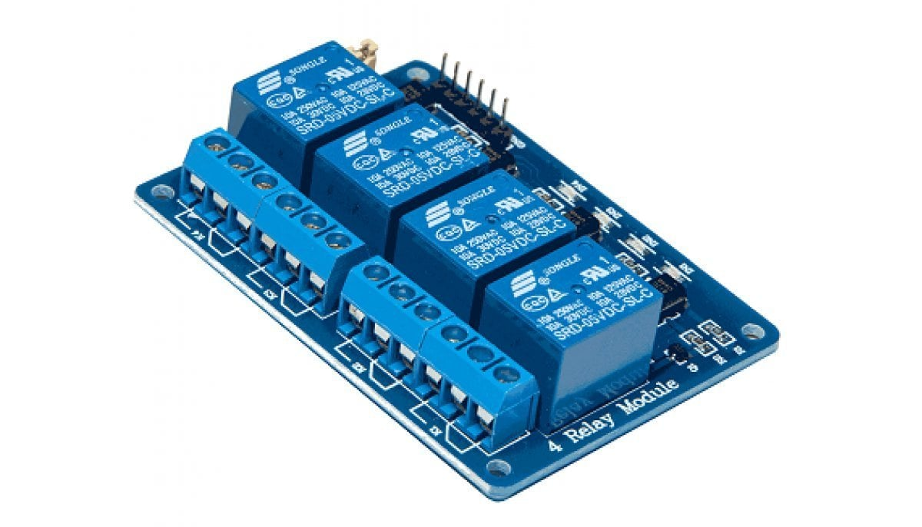

Figure no [1]

The 4-channel relay module (Figure 2) is a practically a switch that is electrically operated by supplying a coil with a small amount of voltage provided by the microcontroller, thus providing a magnetic field that attracts or rejects an electrical contact. The module is used to start or stop a circuit that uses a voltage or current much higher than the one supported by ESP8266. There is no direct contact between the low voltage electronic circuit and the high voltage electrical circuit because there are protected from

each other. Each of the 4 channels has 3 types of

connections called NC (Normal Closed), NO (Normal Open) and COM (Common). The relay module is used high current switching, isolated power delivery and home automation.

Relay module specifications:

- Operating voltage: 3.75V – 6V

- Quiescent current consumption: 2mA

- Current consumption when relay is active:

~70mA

- Maximum contact voltage: 250V A.C, 30V D.C

- Maximum contact current: 10A

- Number of channels: 4

1. ESP8266-:

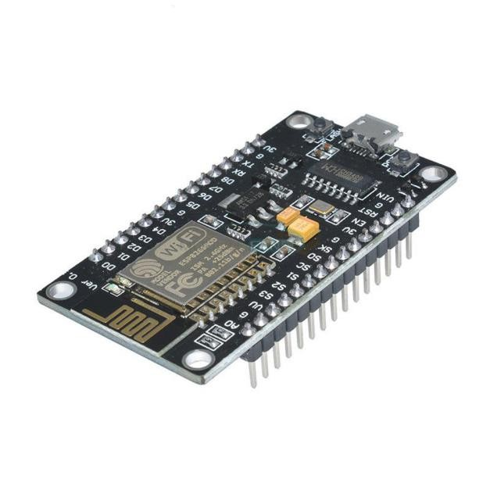

The ESP8266 stands out as a revolutionary component in the realm of embedded systems and the Internet of Things (IoT). Developed by Espressif Systems, this compact and cost-effective Wi-Fi module has garnered widespread acclaim due to its versatility and robust capabilities. At its core lies a potent 32-bit Tensilica L106 microcontroller, orchestrating seamless Wi-Fi connections while also supporting independent operations without the need for an external microcontroller. This fusion of computing power and wireless connectivity positions the ESP8266 as an ideal solution across a multitude of applications. The distinguishing feature of the ESP8266 is its proficiency in delivering reliable Wi-Fi connectivity, enabling devices to effortlessly link to local area networks or the Internet. Its GPIO pins provide flexibility, allowing the module to seamlessly interface with a diverse array of sensors, actuators, and other peripherals, rendering it an optimal choice for IoT projects. Furthermore, its low power consumption makes it suitable for battery-powered applications and environments where energy efficiency is a paramount consideration. A noteworthy attribute of the ESP8266 is its adaptability in programming. Developers can leverage Arduino-compatible C/C++ through the Arduino IDE, delve into high-level programming with MicroPython. or harness Lua's scripting capabilities. This flexibility accommodates developers with varying levels of expertise, making the ESP8266 accessible to a broad audience. The ESP8266 has witnessed the evolution of different versions, each tailored to specific project requirements. From the early ESP-01 to more advanced iterations like the ESP-12E/ESP-12F, the module has adapted to the escalating demands of IoT and embedded systems development. Additionally, the ESP-32, while not a version of the ESP8266, serves as a remarkable successor that builds on its capabilities, introducing features such as dual-core processing and Bluetooth connectivity.

**VII) Software Required**

1. Arduino IDE-:

The Arduino Integrated Development Environment (IDE) serves as a user-friendly software platform designed for programming Arduino microcontrollers. This comprehensive environment encompasses a code editor, a repository of built-in examples, and essential tools like a library manager and serial monitor, streamlining the development process for users. With support for a diverse array of programming languages, the IDE caters to a broad spectrum of developers, making it equally accessible to beginners as well as seasoned professionals.

1. Blynk Iot-:

Blynk is an IoT platform that simplifies IoT application development. It provides a user-friendly mobile application and cloud infrastructure to connect and control devices. Using drag- and-drop widgets, Blynk makes it easy to create custom interfaces, supporting seamless communication and control between users and their IoT devices.

1. ESP8266 Libraries-:

Specific libraries for the ESP8266 module may be required to enable communication with the hardware components and streamline the coding process. Libraries provide pre-written functions and routines that simplify complex tasks, such as establishing.

1. **Working-:**

Home automation using ESP8266 with the Blynk app involves connecting the ESP8266 microcontroller to the Blynk cloud platform, allowing users to remotely control and monitor devices in their homes through a smartphone.

The ESP8266 continuously connects to the Blynk server over Wi-Fi. The Blynk app communicates with the Blynk server. When you interact with widgets in the Blynk app, it sends commands to the Blynk server. The Blynk server forwards these commands to the ESP8266. The ESP8266 reacts to the commands and controls the connected devices accordingly.

1. **Hardware**

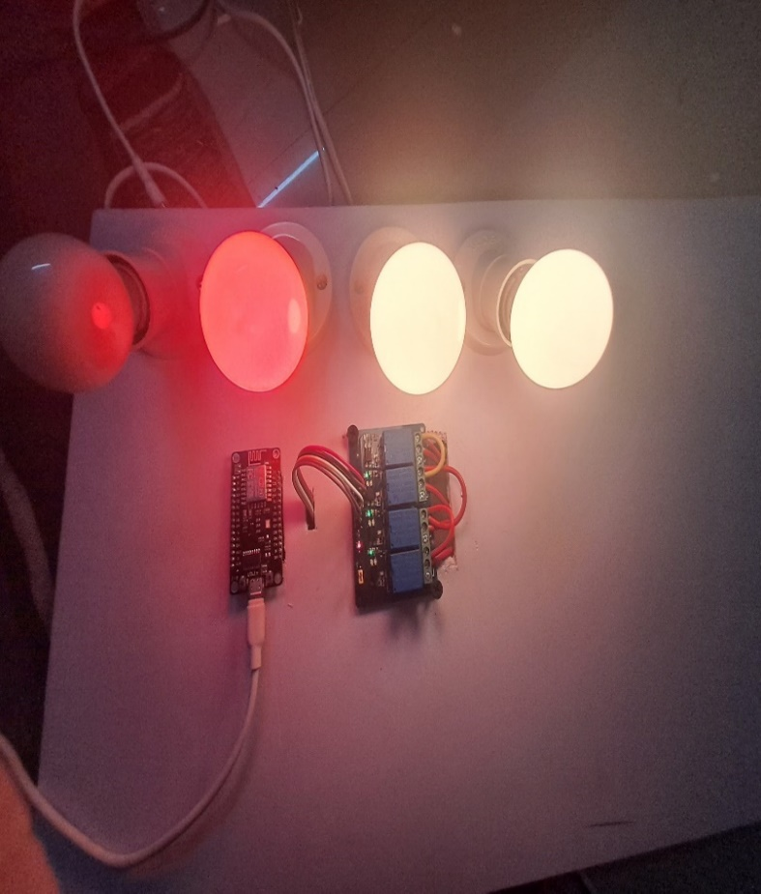

1. **Applications-:**

**Remote Device Control:**

Turn lights, fans, and other appliances on or off remotely using the Blynk app on your smartphone or tablet.

Enjoy the convenience of managing your home environment from anywhere with an internet connection.

**Customizable Interface:**

Create a personalized control dashboard within the Blynk app to suit your preferences.

Arrange buttons, sliders, and other widgets to control specific devices or entire rooms with ease.

**Scenario Automation:**

Set up automation scenarios for routine tasks or specific events.

Schedule actions such as turning off lights at bedtime or activating security measures when leaving home.

**Energy Efficiency:**

Monitor and optimize energy usage by tracking the status of connected devices.

Schedule power-off times for non-essential appliances to reduce appliances.

1. **Results and Discussion**

By utilizing the 4-channel relay with the ESP8266 and Blynk IoT, we achieve a versatile and customizable home automation system that provides remote control and monitoring capabilities for multiple devices. We can remotely control various devices in our home, such as lights, fans, or appliances, through the Blynk app on our smartphone or tablet. The Blynk app provides a user-friendly interface with widgets like buttons or switches, allowing we to toggle the state of the connected devices. We can monitor the real-time status of devices connected to the 4-channel relay through the Blynk app. For example, we can check if lights are on or off. Create automation scenarios using Blynk's features, like setting up timers or triggers. For instance, we can schedule lights to turn on at a specific time or based on sensor inputs. The 4-channel relay provides the capability to control multiple devices simultaneously. Receive feedback on the status of devices. If a light is manually turned on/off at the physical switch, the Blynk app will reflect the updated state. The system relies on internet connectivity for communication between the ESP8266 and the Blynk IoT Cloud. Ensure a stable internet connection for reliable operation. Implement security features such as secure Wi-Fi settings and authentication tokens to protect the communication between the ESP8266 and Blynk IOT. We can easily interact with the home automation system through the Blynk app, making it accessible to individuals without technical expertise.

# **Future Scope**

# The current prototype utilizes a ESP8266 that is programmed to manage home appliances through a Blynk app platform. Looking ahead, there is potential for further development in the integration of sensors such as motion detectors and temperature sensors, enhancing the system's capabilities. These sensors could enable appliances to autonomously respond to environmental parameters via actuators, ultimately leading to a fully automated system. In terms of security, the addition of a CCTV or IP camera with facial recognition features is considered, enabling visual streaming directly to the user's smartphone and issuing notifications in the event of detecting unfamiliar individuals. Additionally, the future implementation includes the incorporation of voice commands in multiple languages for added user convenience.

# **Conclusion**

The proposed project addresses the imperative need for automation at the fundamental level, specifically within our households. While its primary objective is to reduce human effort, its significance extends significantly to elderly individuals and those with physical disabilities. This system aims to centralize control over every appliance within our homes, allowing users to manage them seamlessly from a single point, eliminating the need for manual switching. Furthermore, the system contributes to enhanced security measures and energy conservation. With the ability to access devices through a website, even remotely where Wi-Fi is available, the system proves to be fully functional, ensuring wireless control with remarkable accuracy in performance.

1. **Acknowledgement**

We would like to express my sincere gratitude to Dr, Pravin Gawande Sir, our supervisor and guide throughout our experiment on WiFi based Smart Home Automation with Blynk app using ESP8266. Dr. Gawande’s expertise, guidance, and support were invaluable in the successful completion of this project. His enthusiasm, encouragement, and willingness to share his knowledge and expertise have been truly inspiring.

1. **Referances**
2. Anantha Krishnana J, IOT based Home automation with Speech Recognition.
3. Datasheet Bluetooth to Serial Port Module HC05: <http://www.electronica60norte.com/mwfls/pdf/new> Bluetooth.pdf
4. Gaurav Panwar, Rajat Maurya, Rajesh Rawat, Rohit Kanswal and Praful Ranjan,”Home automation using IOT application”,International Journal of Smart Home Vol. 11, No. 9 (2017), pp. 1-8

<http://dx.doi.org/10.21742/ijsh.2017.11.09.01>

1. Ravi Kishore Kodali, Vishal Jain, Suvadeep Bose andLakshmi Boppana,” IoT Based Smart Security and Home Automation System”, International Conference on Computing, Communication and Automation(ICCCA2016).
2. Abdul Aziz Md,K Harshasri, K Shanmukharao,”Cost Effective Voice Controlled Home Automation Using IoT”,International Journal of Engineering Research in Computer Science and Engineering (IJERCSE),Vol 4, Issue 3, March 2017,ISSN (Online) 2394-2320
3. [6] Al-Ali, Member, IEEE & M. AL-Rousan, “Java-Based Home Automation System”. IEEE Transactions on Consumer Electronics, Vol. 50, No. 2, MAY 2004
4. D Kunal, D Tuscarora Undegaonkar Pooja, Zope Vaibhav,Vinay Lodha “Smart Home Automation using IOT”
5. International Journal of Advanced Research in Computer and Communication Engineering,Vol. 5, Issue 2, February 2016
6. N. Sriskanthan and Tan Karand. “Bluetooth Based Home Automation System”. Journal of Microprocessors and Microsystems, Vol. 26, pp.281-289, 2002.
7. E. Yavuz, B. Hasan, I. Serkan and K. Duygu. “Safe and Secure PIC Based Remote Control Application for Intelligent Home”. International Journal of Computer Science and Network Security, Vol. 7, No. 5, May 2007.
8. Amul Jadhav, S. Anand, Nilesh Dhangare, K.S. Wagh “Universal Mobile Application Development (UMAD) On Home Automation” Marathwada Mitra Mandalʼs Institute of Technology, University of Pune, India
9. Network and Complex Systems ISSN 2224-610X (Paper) ISSN 2225-0603 (Online) Vol 2, No.2, 2012
10. Rana, Jitendra Rajendra and Pawar, Sunil N., Zigbee Based Home automation (April 10, 2010) http://dx.doi.org/10.2139/ssrn.1587245